

**PES University, Bangalore**

(Established under Karnataka Act No. 16 of 2013)

**UE21EC241B- CONTROL SYSTEMS**

**CS- PROJECT**

Session: Jan-May 2023

**Branch: ELECTRONICS AND COMMUNICATION ENGINEERING**

**Semester &Section:4TH SEM , A SECTION**

|  |  |  |  |
| --- | --- | --- | --- |
| **Sl No.** | **Name of the Student** | **SRN** | **Marks Allotted**  **(Out of 5)** |
| 1. | AKASH RAVI BHAT | PES1UG21EC025 |  |
| 2. | ABHISHEK A. SHETTY | PES1UG21EC008 |  |
| 3. | AKASH C.K. | PES1UG21EC022 |  |

Name of the Course Instructor : **Prof. THIPPESWAMY E.**

Signature of the Course Instructor

(with Date) : ___________________________

ANALYSIS OF THE ROLL ANGLE CONTROLLER

* Roll angle control (RAC) is required for the lateral stability of an aircraft. Lateral stability makes the aircraft more stable around the longitudinal axis.
* Roll angle control makes both the wings of the aircraft to be at the same level.
* If one of the wing dips below the other, then RAC tries to stabilize the system again

1. The objective of this experiment is to analysis and design of control systems specific to a physical system. Each student will be given a specific physical system, and experiments are to be conducted on that particular physical system. (The specific physical system will be given to a student by the respective Teacher or Student can select the physical system by themselves.)

a. The objective of this exercise is to obtain the open loop characteristics of the given transfer function of the physical system or plant.

Aim or the outcome of the Project.

Regulate the bank angle of airplane to zero degrees and maintain the wings level orientation in the presence of unpredictable external disturbances.

(i)Where are the poles and zeros of the open loop system? (Exclude the controller, if considered in your

CODE:-

clc;

clear all;

close all;

%Defining the open loop transfer function.

num =[36.6];

den=[1 9.2 15.4 0];

sys= tf(num, den)

% Find's the poles and zeros of open loop system

P =pole(sys)

z = zero(sys)

OUTPUT:-

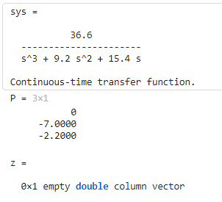

Obtain the ‘pole-zero’ map for the open loop system. Code:

clc;

clear all;

close all;

%Defining the open loop transfer function

num= [36.6];

den = [1 9.2 15.4 0];

sys =tf (num, den)

% Find's the poles and zeros of open loop system

p = pole(sys)

z = zero(sys)

% Plot the pole-zero map

figure;

pzmap (sys);

title('Pole-Zero Map');

OUTPUT:-

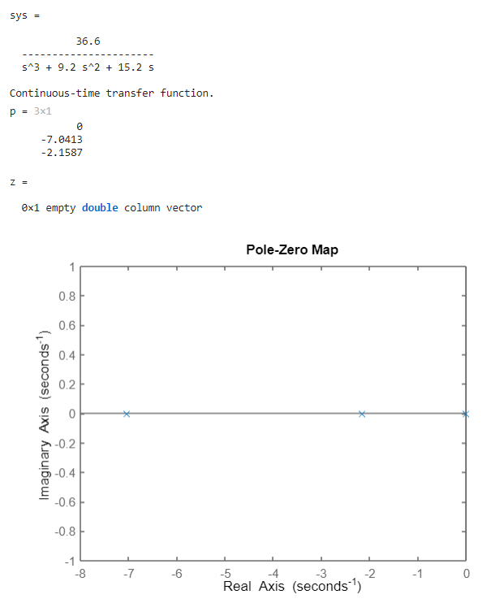

(ii) Apply different test signals, and observe the timedomain response. Discuss the results obtained from the viewpoint of pole-zero map.

MATLAB CODE

s = tf('s')

num = [ 0 0 36.6];

den = [1 9.2 15.4 0];

TF = tf(num,den)

figure

pzmap(TF)

figure

step(TF)

figure

impulse(TF)

figure

title('Ramp response')

step(TF/s) %ramp response

MATLAB OUTPUT

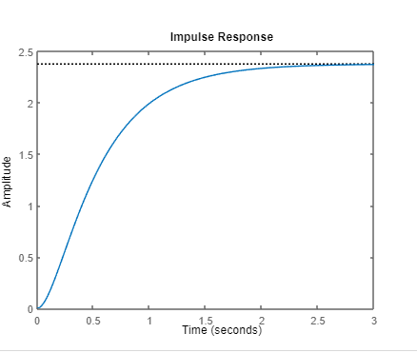

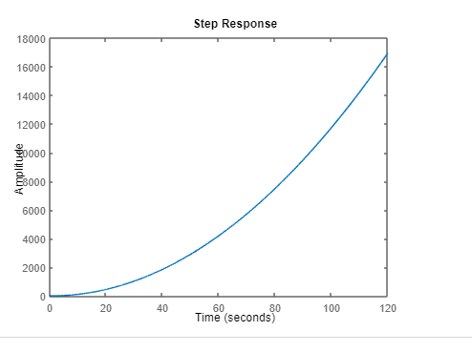

Step input:

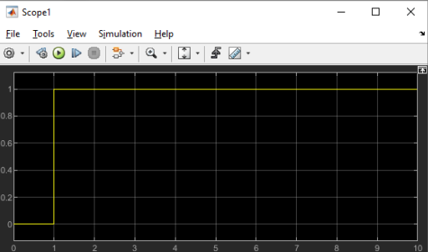

OUTPUT:-

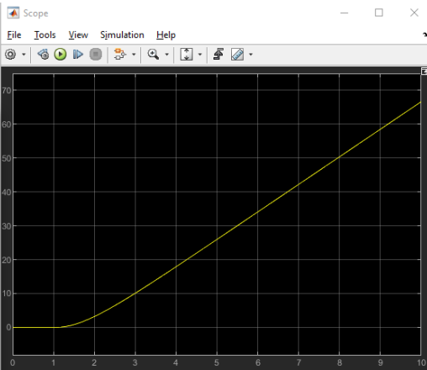

CODE:-

num= [36.6];

den = [1 9.2 15.4 0];

sys=tf (num, den)

stepinfo(sys)

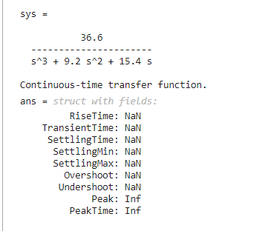

RAMP INPUT

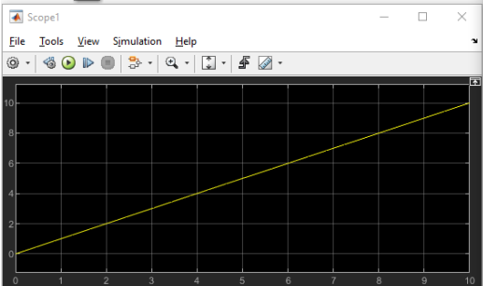

OUTPUT:-

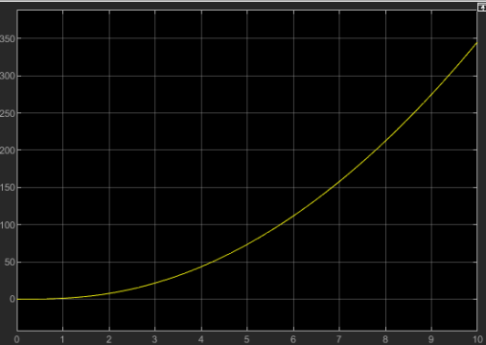

2. The objective of this exercise is to determine the range of a gain that assures closed loop stability. Assume that the given system is part of a unity negative feedback system, and there is a gain in cascade with the given system in the forward path. Conduct experiments similar to (project2-1) and determine the range of k for which the closed loop system is stable

Matlab code

k = [1:1:5];

num = [0 0 0 36.6];

den = [1 9.2 15.4 0];

n1 = conv(num,k(1));

n2 = conv(num,k(2));

n3 = conv(num,k(3));

n4 = conv(num,k(4));

n5 = conv(num,k(5));

d1 = conv(den,1);

[num1,den1] = negfeedback(n1,1,d1,1);

[num2,den2] = negfeedback(n2,1,d1,1);

[num3,den3] = negfeedback(n3,1,d1,1);

[num4,den4] = negfeedback(n4,1,d1,1);

[num5,den5] = negfeedback(n5,1,d1,1);

tf1 = tf(num1,den1);

tf2 = tf(num2,den2);

tf3 = tf(num3,den3);

tf4 = tf(num4,den4);

tf5 = tf(num5,den5);

figure

pzplot(tf1)

figure

pzplot(tf2)

figure

pzplot(tf3)

figure

pzplot(tf4)

figure

pzplot(tf5)

function [num,den] = negfeedback(n1,n2,d1,d2)

num = conv(n1,d2);

den = conv(d1,d2)+conv(n1,n2);

end

output:-

for k=1

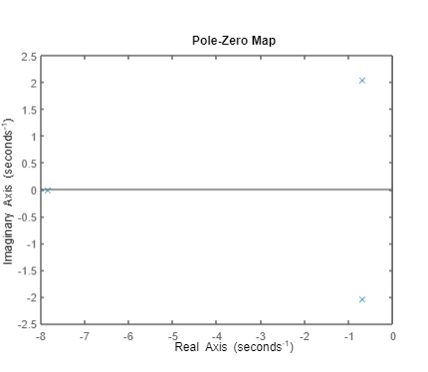

For k=2

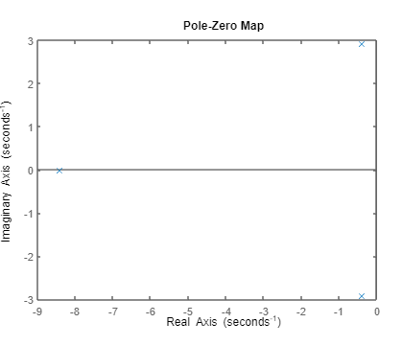

K=3

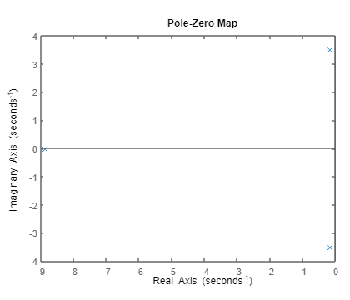

For k=4

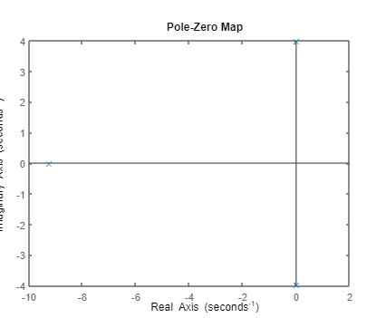

3. The objective of the exercise to analyse the closed loop system behaviour with proportional controller of the system whose transfer function you were given earlier. a. Place a gain k in the forward path, and close the loop with negative unity feedback. Take different values for k. For each value of in this set, obtain the step response. What is the rise time, the settling time? Are there any oscillations? If so, what is the frequency of oscillation? Compare the response of the closed loop system to the open loop system. Compare the closed loop responses. Discuss the results. Can we increase k indefinitely? b. Obtain the root locus. Mark the earlier choices of k on the root locus. Discuss the results obtained from the root locus with reference to those obtained with k in the forward path in part 3(a).

MATLAB CODE

k = [1:1:5];

num = [0 0 0 36.6];

den = [1 9.2 15.4 0];

n1 = conv(num,k(1));

n2 = conv(num,k(2));

n3 = conv(num,k(3));

n4 = conv(num,k(4));

n5 = conv(num,k(5));

d1 = conv(den,1);

[num1,den1] = negfeedback(n1,1,d1,1);

[num2,den2] = negfeedback(n2,1,d1,1);

[num3,den3] = negfeedback(n3,1,d1,1);

[num4,den4] = negfeedback(n4,1,d1,1);

[num5,den5] = negfeedback(n5,1,d1,1);

tf1 = tf(num1,den1);

tf2 = tf(num2,den2);

tf3 = tf(num3,den3);

tf4 = tf(num4,den4);

tf5 = tf(num5,den5);

figure

step(tf1)

stepinfo(tf1)

figure

step(tf2)

stepinfo(tf2)

figure

step(tf3)

stepinfo(tf3)

figure

step(tf4)

stepinfo(tf4)

tf11 = tf(n1,d1);

tf22 = tf(n2,d1);

tf33 = tf(n3,d1);

tf44 = tf(n4,d1);

figure

rlocus(tf11)

rlocus(tf22)

rlocus(tf33)

rlocus(tf44)

function [num,den] = negfeedback(n1,n2,d1,d2)

num = conv(n1,d2);

den = conv(d1,d2)+conv(n1,n2);

end

MATLAB OUTPUT

FOR K=1

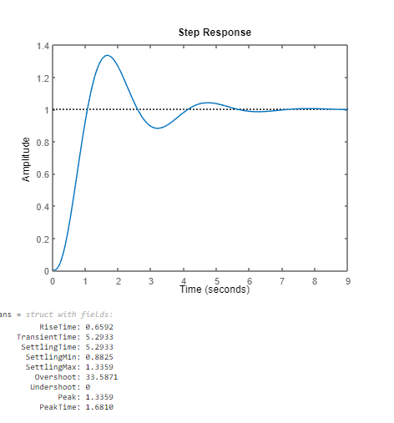

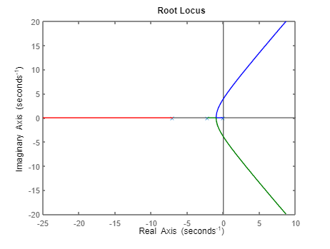

FOR K=2

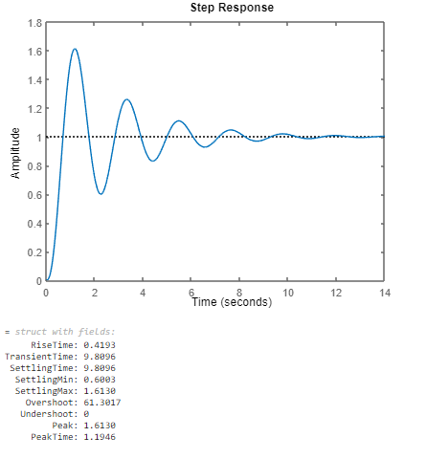

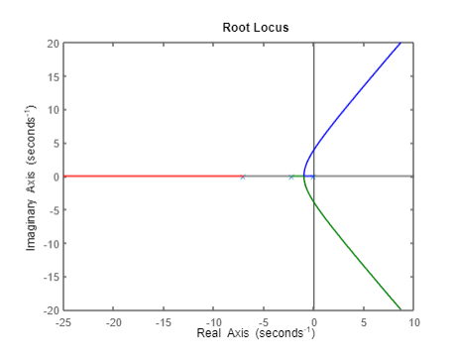

FOR K=3

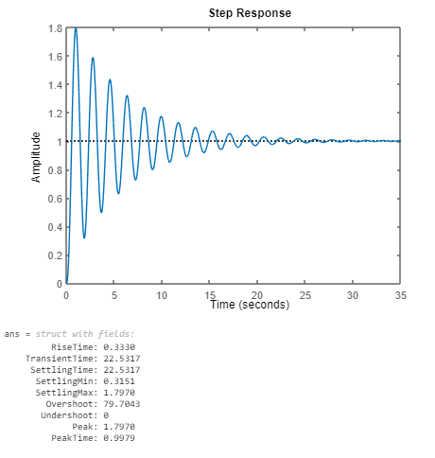

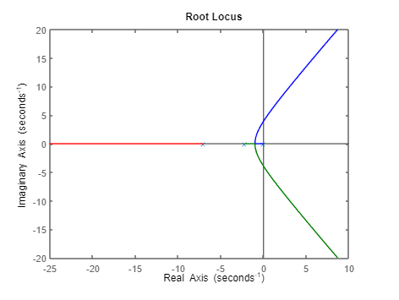

FOR K=4

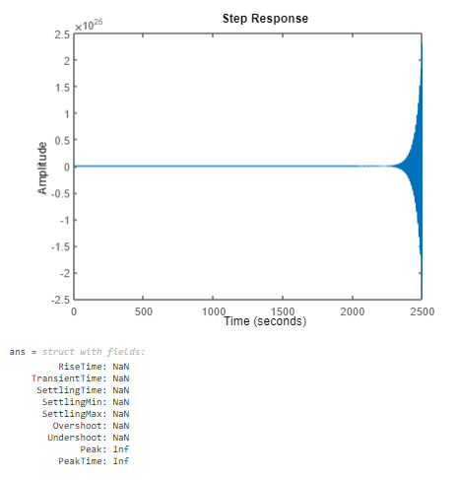

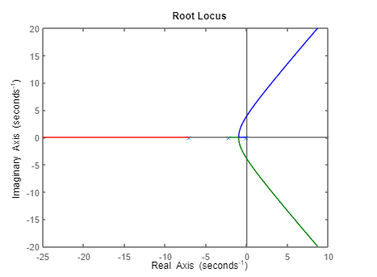

4. The objective of this exercise is to obtain the closed loop behaviour with proportional plus derivative controller of the system you were given earlier. Place a function K (s + z) in the forward path, and close the loop with negative unity feedback. Take different values for K and z. For each sets of (K,z) obtain the step response, and the rlocus. Compare the step response for each case, and compare with the case of putting only a gain K in the forward path. What is therefore the effect of adding a zero in the forward path? Are there any additional insight to be gained from the rlocus: Obtain the root locus for each case. Compare the three loci, and discuss the results.

MATLAB CODE

num = [0 0 0 36.6];

den = [0 1 9.2 15.4 0];

k=1,z=1

n1 = conv([1 1],num);

[num1,den1] = negfeedback(n1,1,den,1);

tf1 = tf(num1,den1);

tf11 = tf(n1,den);

figure;

step(tf1)

stepinfo(tf1)

figure;

rlocus(tf11)

k=2,z=1

n2 = conv([2 2],num);

[num2,den2] = negfeedback(n2,1,den,1);

tf2 = tf(num2,den2);

tf22 = tf(n2,den);

figure;

step(tf2)

stepinfo(tf2)

figure;

rlocus(tf22)

k=1,z=2

n3 = conv([1 2],num);

[num3,den3] = negfeedback(n3,1,den,1);

tf3 = tf(num3,den3);

tf33 = tf(n3,den);

figure;

step(tf3)

stepinfo(tf3)

figure;

rlocus(tf33)

k=3,z=2

n4 = conv([3 6],num);

[num4,den4] = negfeedback(n4,1,den,1);

tf4 = tf(num4,den4);

tf44 = tf(n4,den);

figure;

step(tf4)

stepinfo(tf4)

figure;

rlocus(tf44)

k=5,z=7

n5 = conv([5 35],num);

[num5,den5] = negfeedback(n5,1,den,1);

tf5 = tf(num5,den5);

tf55 = tf(n5,den);

figure;

step(tf5)

stepinfo(tf5)

figure;

rlocus(tf55)

k=9,z=13

n6 = conv([9 117],num);

[num6,den6] = negfeedback(n6,1,den,1);

tf6 = tf(num6,den6);

tf66 = tf(n6,den);

figure;

step(tf6)

stepinfo(tf6)

figure;

rlocus(tf66)

k=2,z=13

n7 = conv([2 26],num);

[num7,den7] = negfeedback(n7,1,den,1);

tf7 = tf(num7,den7);

tf77 = tf(n7,den);

figure;

step(tf7)

stepinfo(tf7)

figure;

rlocus(tf77)

function [num,den] = negfeedback(n1,n2,d1,d2)

num = conv(n1,d2);

den = conv(d1,d2)+conv(n1,n2);

end

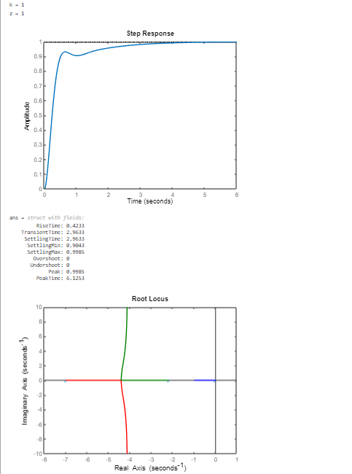

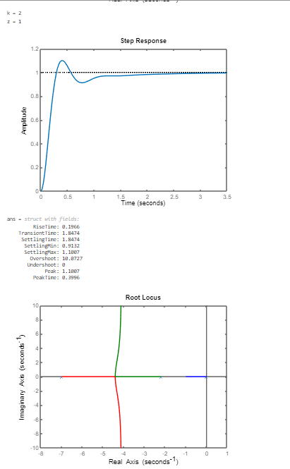

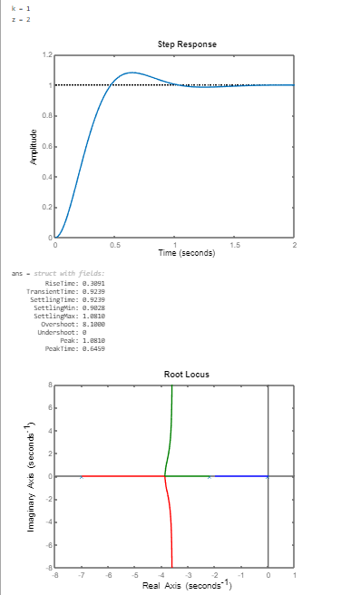

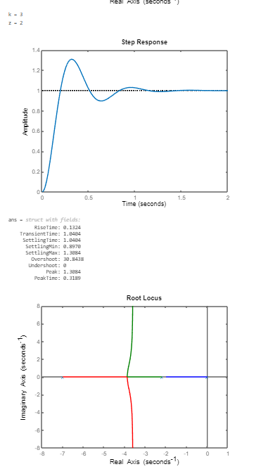

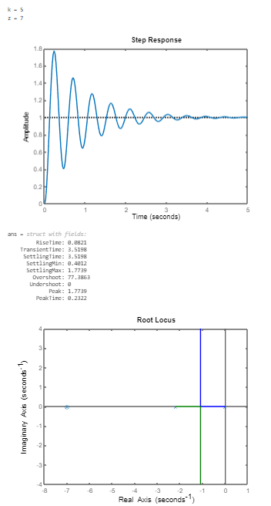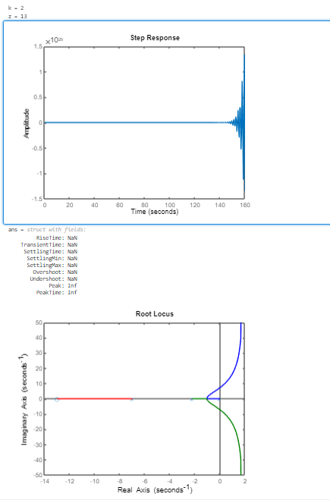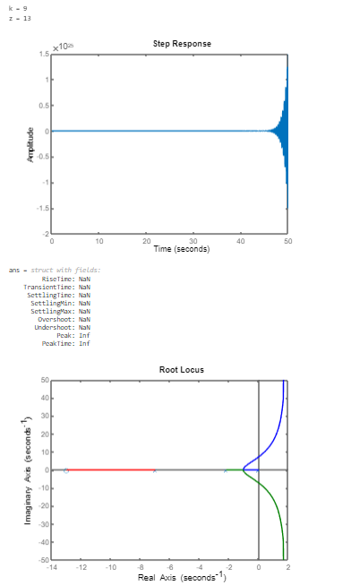

5. (a)The objective of this exercise is to obtain the closed loop behaviour with proportional plus integral controller of the system you were given earlier. (i) Place a function ((𝑠 + 𝑧)/𝑠) in the forward path, and close the loop with negative unity feedback. Take different values for 𝐾 and 𝑧, For each sets of (𝐾, 𝑧)obtain the step response, and the root locus. Compare the step response for each case, and compare with the case of putting only a gain 𝐾in the forward path and (𝑠 + 𝑧). What is therefore the effect of adding a pole in the forward path? Are there any additional insights to be gained from the root locus. Compare the three loci, and discuss the results. Hence (ii) infer the results if the following function 𝐾1 + 𝐾2 𝑠 + 𝐾3𝑠 is placed in the forward path. Substantiate your answer for suitable choices of 𝐾1,2 and 𝐾3

MATLAB CODE

num = [0 0 0 36.6];

den = [1 9.2 15.4 0 0];

k=1,z=1

n1 = conv([1 1],num);

[num1,den1] = negfeedback(n1,1,den,1);

tf1 = tf(num1,den1);

tf11 = tf(n1,den);

figure;

step(tf1)

stepinfo(tf1)

figure;

rlocus(tf11)

k=2,z=1

n2 = conv([2 2],num);

[num2,den2] = negfeedback(n2,1,den,1);

tf2 = tf(num2,den2);

tf22 = tf(n2,den);

figure;

step(tf2)

stepinfo(tf2)

figure;

rlocus(tf22)

k=1,z=2

n3 = conv([1 2],num);

[num3,den3] = negfeedback(n3,1,den,1);

tf3 = tf(num3,den3);

tf33 = tf(n3,den);

figure;

step(tf3)

stepinfo(tf3)

figure;

rlocus(tf33)

k=3,z=2

n4 = conv([3 6],num);

[num4,den4] = negfeedback(n4,1,den,1);

tf4 = tf(num4,den4);

tf44 = tf(n4,den);

figure;

step(tf4)

stepinfo(tf4)

figure;

rlocus(tf44)

k=5,z=7

n5 = conv([5 35],num);

[num5,den5] = negfeedback(n5,1,den,1);

tf5 = tf(num5,den5);

tf55 = tf(n5,den);

figure;

step(tf5)

stepinfo(tf5)

figure;

rlocus(tf55)

k=9,z=13

n6 = conv([9 117],num);

[num6,den6] = negfeedback(n6,1,den,1);

tf6 = tf(num6,den6);

tf66 = tf(n6,den);

figure;

step(tf6)

stepinfo(tf6)

figure;

rlocus(tf66)

k=2,z=13

n7 = conv([2 26],num);

[num7,den7] = negfeedback(n7,1,den,1);

tf7 = tf(num7,den7);

tf77 = tf(n7,den);

figure;

step(tf7)

stepinfo(tf7)

figure;

rlocus(tf77)

function [num,den] = negfeedback(n1,n2,d1,d2)

num = conv(n1,d2);

den = conv(d1,d2)+conv(n1,n2);

end

MATLAB OUTPUT:-

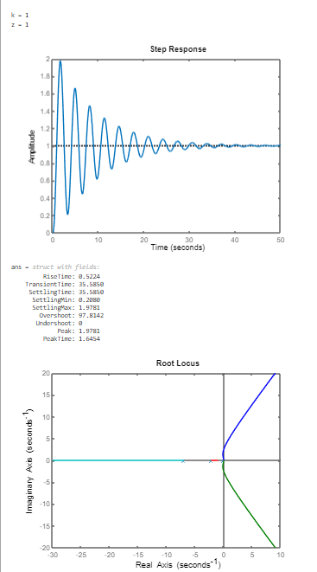

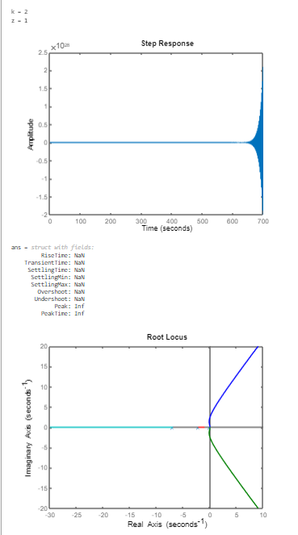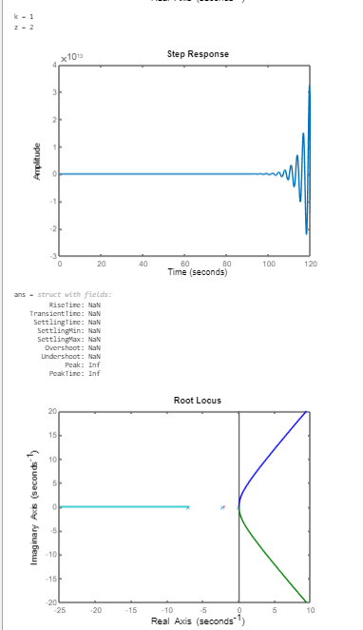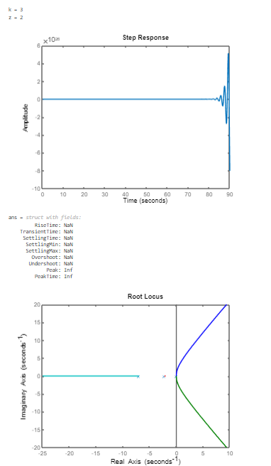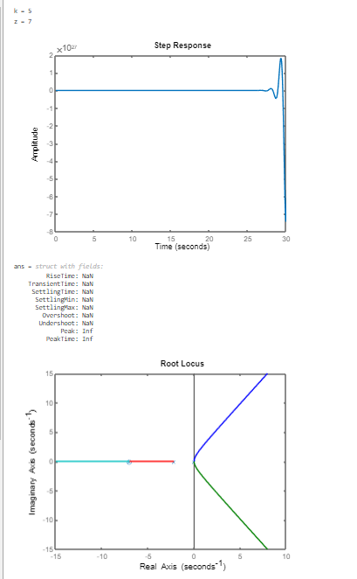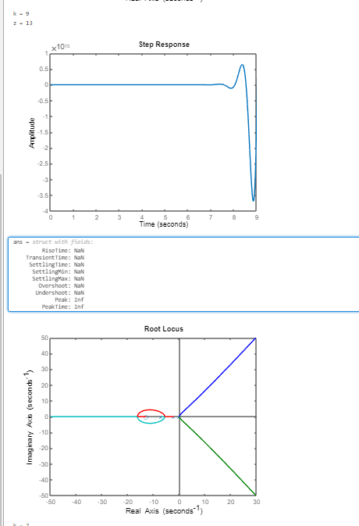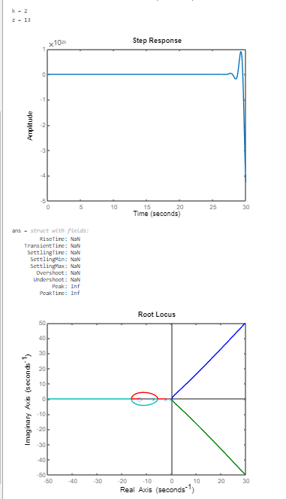

6. (b) The objective of this exercise is to analyse the system in frequencydomain. Obtain the Bode and Nyquist plot for the system you were given earlier. What are the gain and phase margins? What can you conclude about the stability of your system? The objective of this exercise is to obtain the closed loop behaviour with Lead or Lag compensator of the system you were given earlier. (i) Place a function (𝜏𝑠+1) 𝛼(𝛼𝜏𝑠+1) in the forward path, and close the loop with negative unity feedback for Lag compensator and 𝐾(𝛼𝜏𝑠+1) 𝛼(𝜏𝑠+1) for Lead compensator. For fixed K, take different values for 𝛼 and 𝜏, For each sets of (𝛼, 𝜏)obtain the Bode and Nyquist plots of the modified transfer function. Determine the phase and gain margins and also determine the step response of the closed loop transfer function. In addition, obtain the root locus plot. Discuss the results, and draw conclusions. Compare the results with P, PD in the forward path

num = [0 0 0 36.6];

den = [1 9.2 15.4 0];

tfm = tf(num,den);

figure

bode(tfm)

figure

nyquist(tfm)

%Lag compensator

num = [0 0 0 36.6];

den = [1 9.2 15.4 0];

K=1

alpha=2, tau=1

n1 = conv([1 1],num);

d1 = conv([4 2],den);

g1 = tf(n1,d1);

figure

bode(g1)

figure

nyquist(g1)

figure

rlocus(g1)

[n11,d11] = negfeedback(n1,1,d1,1);

tf1 = tf(n11,d11);

figure

step(tf1)

stepinfo(tf1)

alpha=3, tau=2

n2 = conv([2 1],num);

d2 = conv([18 3],den);

g2 = tf(n2,d2);

figure

bode(g2)

figure

nyquist(g2)

figure

rlocus(g2)

[n22,d22] = negfeedback(n2,1,d2,1);

tf2 = tf(n22,d22);

figure

step(tf2)

stepinfo(tf2)

alpha=4, tau=7

n3 = conv([7 1],num);

d3 = conv([112 4],den);

g3 = tf(n3,d3);

figure

bode(g3)

figure

nyquist(g3)

figure

rlocus(g3)

[n33,d33] = negfeedback(n3,1,d3,1);

tf3 = tf(n33,d33);

figure

step(tf3)

stepinfo(tf3)

alpha=1, tau=7

n4 = conv([7 1],num);

d4 = conv([7 1],den);

g4 = tf(n4,d4);

figure

bode(g4)

figure

nyquist(g4)

figure

rlocus(g4)

[n44,d44] = negfeedback(n4,1,d4,1);

tf4 = tf(n44,d44);

figure

step(tf4)

stepinfo(tf4)

alpha=9, tau=5

n5 = conv([5 1],num);

d5 = conv([315 9],den);

g5 = tf(n5,d5);

figure

bode(g5)

figure

nyquist(g5)

figure

rlocus(g5)

[n55,d55] = negfeedback(n5,1,d5,1);

tf5 = tf(n55,d55);

figure

step(tf5)

stepinfo(tf5)

%Lead compensator

num = [0 0 0 36.6];

den = [1 9.2 15.4 0];

K=1

alpha=2, tau=1

n1 = conv([2 1],num);

d1 = conv([2 2],den);

g1 = tf(n1,d1);

figure

bode(g1)

figure

nyquist(g1)

figure

rlocus(g1)

[n11,d11] = negfeedback(n1,1,d1,1);

tf1 = tf(n11,d11);

figure

step(tf1)

stepinfo(tf1)

alpha=3, tau=2

n2 = conv([6 1],num);

d2 = conv([6 3],den);

g2 = tf(n2,d2);

figure

bode(g2)

figure

nyquist(g2)

figure

rlocus(g2)

[n22,d22] = negfeedback(n2,1,d2,1);

tf2 = tf(n22,d22);

figure

step(tf2)

stepinfo(tf3)

alpha=4, tau=7

n3 = conv([28 1],num);

d3 = conv([28 4],den);

g3 = tf(n3,d3);

figure

bode(g3)

figure

nyquist(g3)

figure

rlocus(g3)

[n33,d33] = negfeedback(n3,1,d3,1);

tf3 = tf(n33,d33);

figure

step(tf3)

stepinfo(tf3)

alpha=1, tau=7

n4 = conv([7 1],num);

d4 = conv([7 1],den);

g4 = tf(n4,d4);

figure

bode(g4)

figure

nyquist(g4)

figure

rlocus(g4)

[n44,d44] = negfeedback(n4,1,d4,1);

tf4 = tf(n44,d44);

figure

step(tf4)

stepinfo(tf4)

alpha=9, tau=5

n5 = conv([35 1],num);

d5 = conv([35 9],den);

g5 = tf(n5,d5);

figure

bode(g5)

figure

nyquist(g5)

figure

rlocus(g5)

[n55,d55] = negfeedback(n5,1,d5,1);

tf5 = tf(n55,d55);

figure

step(tf5)

stepinfo(tf5)

function [num,den] = negfeedback(n1,n2,d1,d2)

num = conv(n1,d2);

den = conv(d1,d2)+conv(n1,n2);

end

MATLAB OUTPUT:-

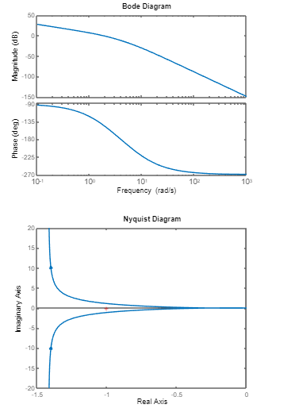

LAG COMPENSATOR:-

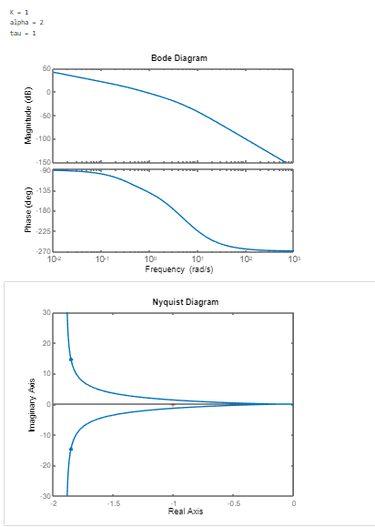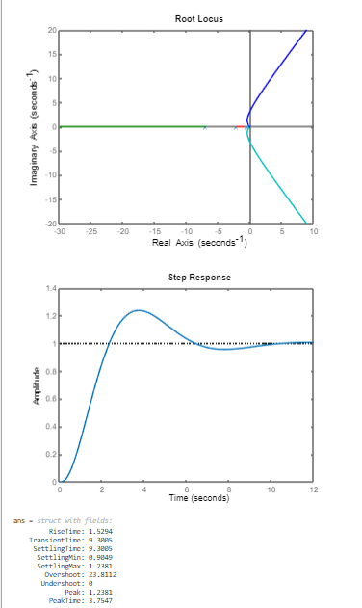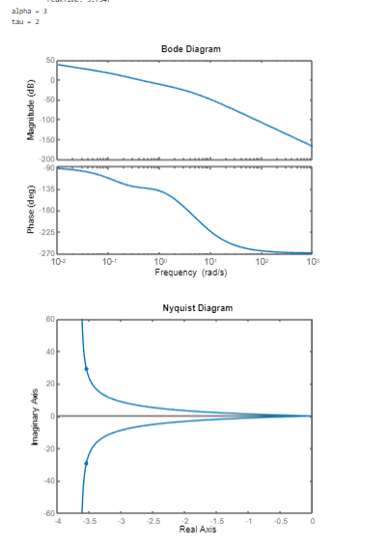

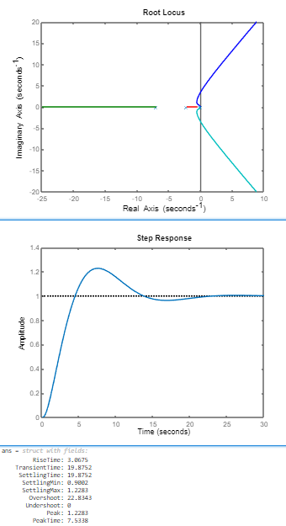

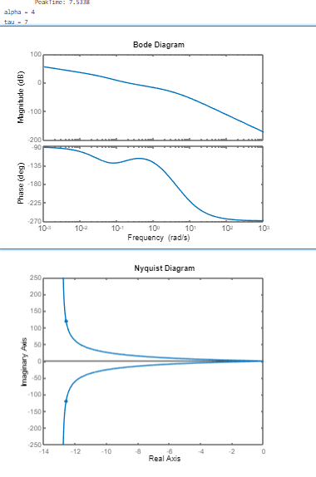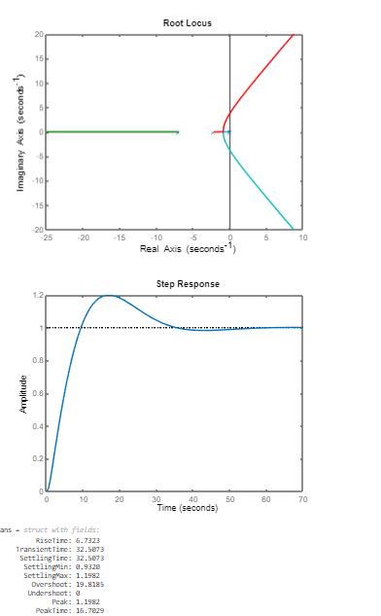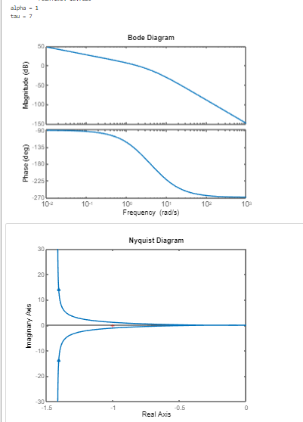

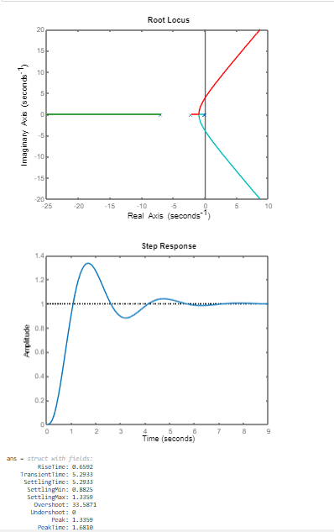

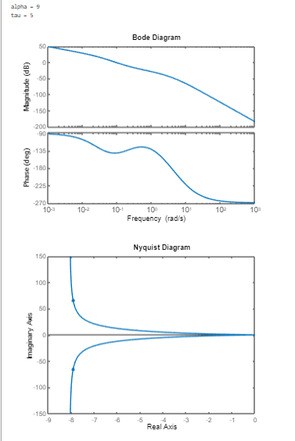

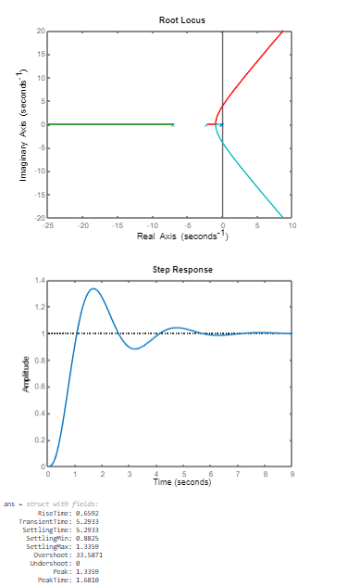

LEAD COMPENSATOR

